1. Create a program with the following:

There are 3 ways to pass C++ arguments to a function:

1. call-by-value
2. call-by-reference with pointer argument
3. call-by-reference with reference argument

Output:

address of n1 in main(): 0x7ffcdb2b4a44

address of n1 in square1(): 0x7ffcdb2b4a2c

Square of n1: 64

No change in n1: 8

address of n2 in main(): 0x7ffcdb2b4a48

address of n2 in square2(): 0x7ffcdb2b4a48

Square of n2: 64

Change reflected in n2: 64

address of n3 in main(): 0x7ffcdb2b4a4c

address of n3 in square3(): 0x7ffcdb2b4a4c

Square of n3: 64

Change reflected in n3: 64

#include<iostream>

#include<cmath>

using namespace std;

int main(){

    int n1;

    int square1;

    n1=8;

    cout << "address of n1 in main(): " << &n1 << "\n";

    square1=pow(n1,2);

    cout << "address of n1 in square1(): " << &square1 << "\n";

    cout << "Square of n1: " << square1 << "\n";

    cout << "No change in n1: " << n1 << "\n";

    int \*n2;

    int square2;

    \*n2=64;

    square2=\*n2;

    cout << "address of n2 in main(): " << &n2 << "\n";

    cout << "address of n2 in square2(): " << &square2 << "\n";

    cout << "Square of n2: " << \*n2 << "\n";

    cout << "Change reflected in n2: " << \*n2 << "\n";

    int n3;

    int square3;

    n3=64;

    square3=n3;

    cout << "address of n3 in main(): " << &n3 << "\n";

    cout << "address of n3 in square3(): " << &square3 << "\n";

    cout << "Square of n3: " << n3 << "\n";

    cout << "Change reflected in n3: " << n3 << "\n";

}

1. Using arithmetic operations that can be performed on pointers on array.

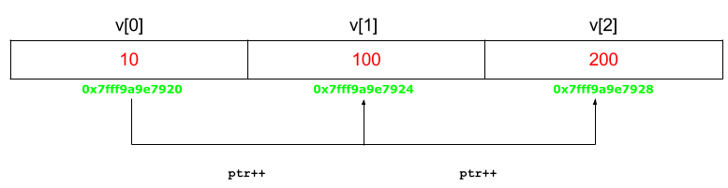int v[3] = {10, 100, 200};

Output:

Value at ptr = 0x7fff9a9e7920

Value at \*ptr = 10

Value at ptr = 0x7fff9a9e7924

Value at \*ptr = 100

Value at ptr = 0x7fff9a9e7928

Value at \*ptr = 200

#include<iostream>

using namespace std;

int main(){

    int v[3] = {10, 100, 200};

    int \*a;

    a=v;

    cout << "Value at ptr = " << a << "\n";

    cout << "Value at \*ptr = " << \*a << "\n";

    a++;

    cout << "Value at ptr = " << a << "\n";

    cout << "Value at \*ptr = " << \*a << "\n";

    a++;

    cout << "Value at ptr = " << a << "\n";

    cout << "Value at \*ptr = " << \*a << "\n";

}

1. Create program let the users to key movie name and movie type. Display the value using pointer to structures.

Output:

Enter title: Invasion of the body snatchers

Enter year: 1978

You have entered:

Invasion of the body snatchers (1978)

#include<iostream>

using namespace std;

struct movie{

    string title;

    int year;

};

int main(){

    movie \*a,b;

    a=&b;

    cout << "Enter title: ";

    cin>>(\*a).title;

    cout << "\nEnter year: ";

    cin>>(\*a).year;

    cout << "\nYou have entered:\n";

    cout << (\*a).title << " (" << (\*a).year << ")\n";

    cout << &b << " (" << &b << ")";

}